Biologically Important Molecules
AP Biology
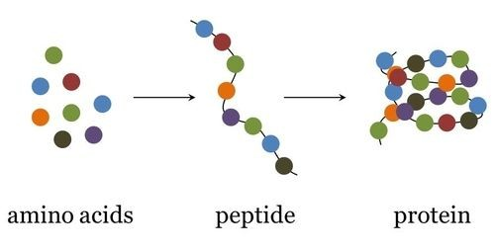
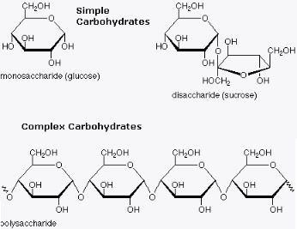
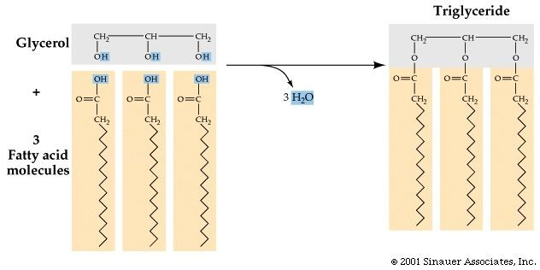
OBJECTIVES: When you finish this activity, you will be able to
- Explain the connection between the sequence and the subcomponents of a biological polymer and its properties.
- Refine representations and models to explain how the subcomponents of a biological polymer and their sequence determine the properties of that polymer.
- Use models to predict and justify that changes in the subcomponents of a biological polymer affect the functionality of the molecule.
- Construct explanations based on evidence of how variation in molecular units provides cells with a wider range of functions.

A sample of some of the molecules you will build and identify in this activity.

Introduction
We have already seen in our study of biochemistry that the molecules that comprise living things are carbon-based, and that they are thought to have originated from inorganic molecules. It is thought that in living organisms, there are over 10,000 compounds that exist to help the organism function These
compounds belong to four major groups of biologically important molecules that perform four major functions in living things:
- Energy storage
- Cellular structure
- Cellular regulation and communication
- Information storage and transfer

But what do these molecules have in common? Are there detectable patterns that exist among groups of molecules in living organisms? How are these molecules assembled? We’ll explore the answers to those questions in this activity.

Finding Patterns in Biologically Important Molecules

The molecules that make life possible are built off of carbon backbones, which act as scaffolds for the other atoms found in organic molecules--namely hydrogen, oxygen, nitrogen, phosphorus and sulfur. But these atoms are not usually found as solo atoms branched off of the carbon backbones. They are most often found as groups of atoms known as functional groups. These functional groups are clusters of atoms found

together that provide molecules with certain chemical properties, such as polarity or acidity. The most important functional groups found in biologically important molecules are shown in the charts below.

Functional Groups: These are the most common functional groups found in the four classes of biologically important molecules we’ll be exploring.

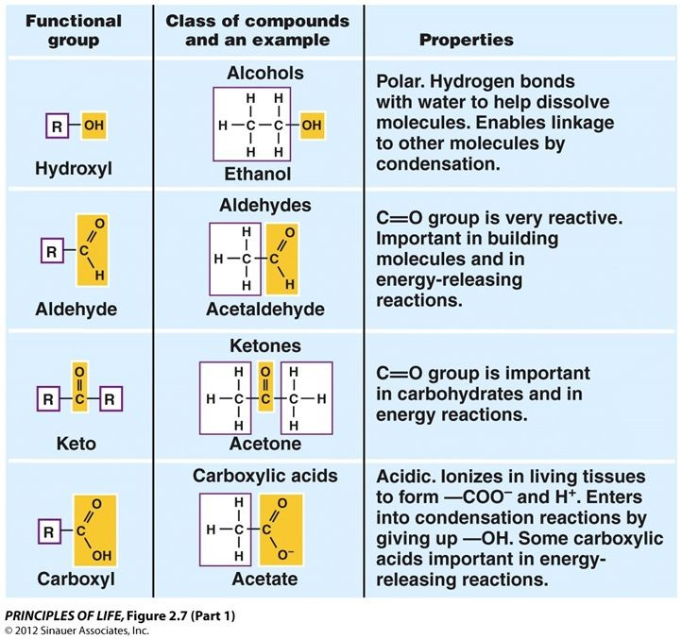
DIRECTIONS:
First, cut apart the molecule cards you have been given. There are 42 different biomolecules on these cards.

Next, identify and mark the functional groups you see on the molecule cards in the following way:
  - Hydroxyl groups: circle in red
  - Aldehydes & Ketones: triangle in orange
  - Carboxyl group: box the group in green
  - Amino group: triangle in yellow
  - Phosphate group: circle in purple
  - Sulfhydryl group: box the group in blue

Now organize the molecule cards into groups based on similarities in their structure. When grouping the molecules, pay close attention to the following:
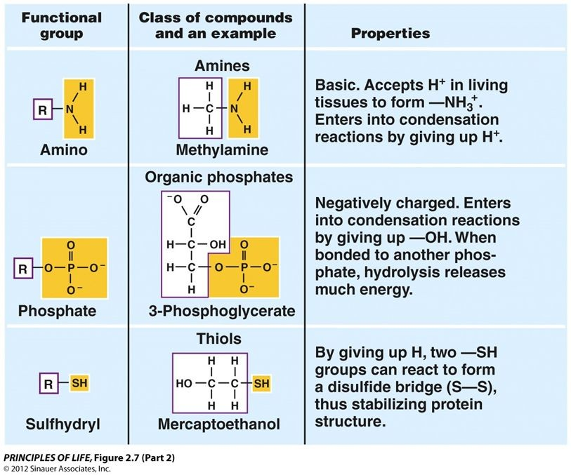
- The functional groups that are present
- The shape of the molecule
- Any patterns you see within the molecule

Now let’s look at the four major groups of biologically important molecules:
- Carbohydrates
- Lipids (includes steroids and fatty acids)
- Nucleic Acids
- Amino Acids

GROUP 1: Carbohydrates

Monosaccharides (simple sugars) are the building blocks of carbohydrates. They are literally hydrates of carbon, having the general formula Cn(H2O)n. Sugars are burned (oxidized) to release energy in cellular respiration and they play an important role in homeostasis. Your body maintains the level of the sugar glucose in your blood within a very narrow range. Glucose is the immediate source of energy for your cells.

Sugars occur as ring structures. There are monosaccharides (found as single rings), disaccharides (found as double rings), and polysaccharides (3+ rings). When in aqueous solution, sugars found as single rings can dynamically change from straight chains to rings and back to straight chains. The same sugar molecule shown in ring and straight chain form is shown below. Notice that every carbon has an oxygen attached to it.
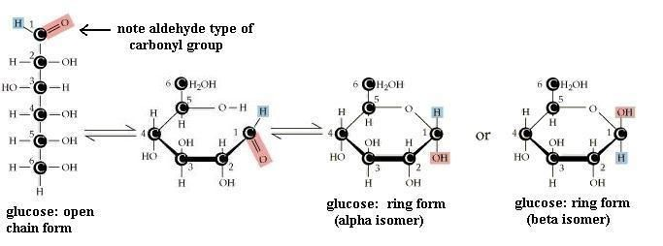
It should also be noted that glucose can be found as an isomer. An isomer is a compound that has the same chemical formula but a different physical structure. Also notice that the carbon atoms are numbered in the moecules above. This will become important when we learn about nucleic acid structure and function.

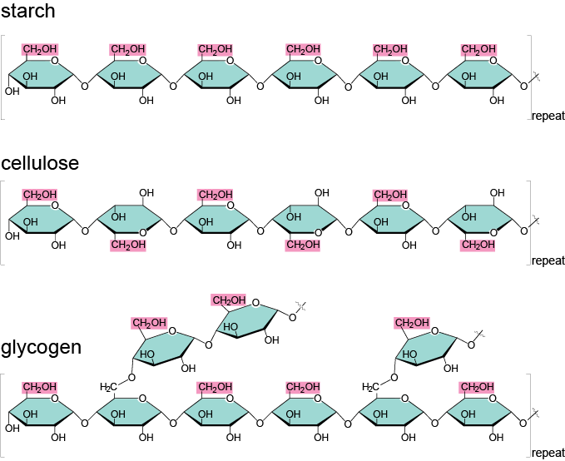
Sugars can be joined together in long chains to form macromolecules called polysaccharides. Starch, cellulose, and glycogen are examples of polysaccharides. Starch (in plants) and glycogen (in animals) are easily broken down into sugars for energy. Cellulose, on the other hand, which is made in plants, can be broken down only by a few organisms in the world (primarily the bacteria in the guts of termites and herbivorous animals such as cows and sheep). Yet all three types of macromolecules are made of long chains of sugar, and cellulose differs only by a small change in the connecting bond between each pair of sugars.

GROUP 2: Lipids
DIRECTIONS:
- In your BILL, create the heading “Monosaccharides.”
- Underneath the heading, paste the 8 monosaccharide molecule cards to the page.
- Finally, create the heading “Disaccharides” and paste the two disaccharide sugars into your BILL under this heading.

There are several types of lipids made and used by living organisms, including:
- triglyceride fats
- phospholipids
- steroids
Lipids are a diverse group of molecules but all types of lipids share one important characteristic: they are all hydrophobic and are thus insoluble in water. Like carbohydrates, they are composed of carbon, hydrogen and oxygen but the ratios of each atom differ from that of carbohydrates.

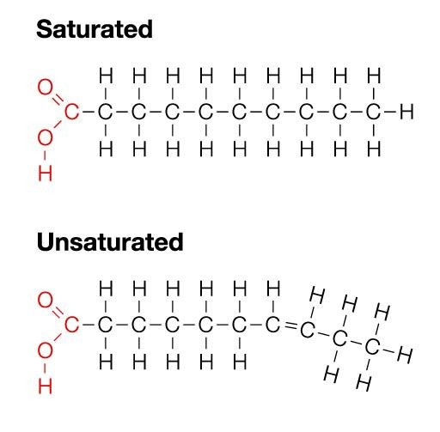
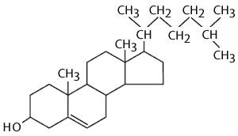
The first group of lipids we’ll examine is the triglyceride fats, composed of glycerol and fatty acids.

In your set of molecule cards, you should have some long hydrocarbon chains with a carboxyl group at one end. One of the defining features of these hydrocarbon chains is the absence of oxygen except in one carboxyl group at one end of the molecule. These hydrocarbon chains are fatty acids. Along with a small
- carbon molecule called glycerol, fatty acids are the building blocks of oils and fats. There are two types of fatty acid structures you should familiarize yourself with: saturated and unsaturated.

The second group of lipids we’ll examine is the steroids. Steroids are a type of lipid formed of four carbon rings fused together. Looking at the diagram of cholesterol shown at right, you’re probably thinking, “But there’s no carbon in the rings!” It should be noted that organic chemists use shortcuts when representing complex structures of organic molecules, so what you are seeing at right is a skeletal formula for cholesterol.

Because organic molecules include so many carbon atoms,
chemists often do not include the letter C for carbon. In the cholesterol molecule above, there is a carbon atom (not drawn in most cases) at every point of each of the four rings and in the side chain. The bonds between the carbons are shown. In all but one case the carbon atoms are connected to one another by a single bond (one pair of shared electrons). In one ring there are two carbon atoms connected by a double bond (which means they are sharing two electrons). To further simplify this drawing, many of the hydrogen atoms have not been drawn. However, since each carbon atom forms four bonds, it is assumed that the bonds not depicted are to hydrogen atoms.

Cholesterol serves two important roles in cells: it is a major component of cell membranes, and it also serves as the building block for the hormones testosterone, cortisol and estrogen.
DIRECTIONS:
- In your BILL, create the heading “Example Lipids: Triglyceride Fats” and paste the 4 components of triglyceride fats underneath. You should also paste the two examples of triglyceride fats here as well.
- Identify each fatty acid and triglyceride fat as either saturated or unsaturated.
- Next, create the heading “Example Lipids: Steroids” and paste the 3 steroid molecules underneath.

GROUP 3: Nucleic Acids

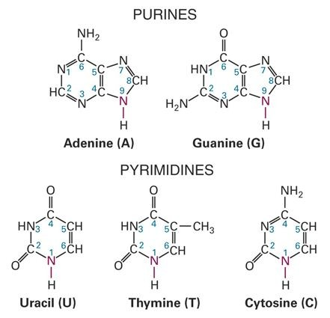
Nucleic acids include two kinds of molecules, RNA (ribonucleic acid) and DNA (deoxyribonucleic acid), and their monomers, nucleotides. In most organisms, DNA contains the genetic blueprint for the organism and is reproduced in its entirety in nearly every cell of its body. RNA helps to translate the information in DNA into the production of thousands of different kinds of proteins, which in turn control development of the organism. A unique characteristic of the nucleic acids is the presence of a nitrogenous base. The nitrogenous bases consist of single or double rings. Each ring contains two nitrogen atoms. DNA contains four nitrogenous bases: adenine(A) and guanine (G), each with double rings, and cytosine (C), and thymine (T), with single rings. RNA contains three of these, A, G, and C, and a fourth base, uracil (U).

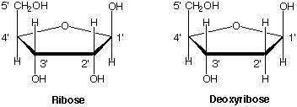
The nitrogenous bases found in nucleic acids are only one component of the monomers of nucleic acids. The monomer of nucleic acids is called a nucleotide and is composed of 3 things: a nitrogen base, a 5-carbon sugar, and a phosphate group. The sugars found in nucleotides are monosaccharide sugars known as pentoses, because they only have 5 carbons arranged in a ring shape.

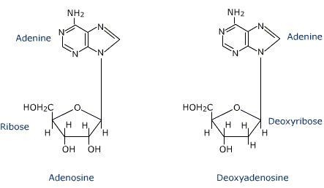
When a nitrogenous base is attached to a 5-carbon sugar, it is known as a nucleoside.
Nucleosides can combine with one, two or three phosphates to form a nucleotide. The greater the number of phosphates, the greater the energy contained in the molecule. Cyclic adenosine monophosphate (cAMP), derived from ATP, is used as a second messenger molecule in some cellular signaling pathways. Adenosine diphosphate (ADP) is an intermediate molecule that is phosphorylated (has a phosphate group attached) in many metabolic pathways and is used to transfer energy between molecules in order for cells to perform work.

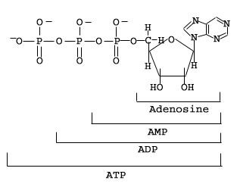
Adenine triphosphate (ATP) is not only a major subunit of DNA and RNA, but also is a major energy carrier in living systems. You can see that it has a nitrogenous base (adenine), a 5-carbon sugar (ribose) and three phosphate groups.
DIRECTIONS:
- Create the heading “Nitrogenous Bases” and paste the 5 nitrogenous base molecule cards underneath.
- Identify each as either a purine or a pyrimidine and label them appropriately.
- Create the heading “Nucleosides” and paste the 4 nucleoside molecule cards underneath. Label the sugar of each as either ribose or deoxyribose.
- Create the heading “Nucleotides” and paste the 3 nucleotide molecule cards underneath. Label the sugar of each as either ribose or deoxyribose.

GROUP 4: Amino Acids
Amino acids are the monomers of proteins, biologically important molecules that perform a multitude of functions in organisms, including:
structural proteins defense (as in antibodies) transport of molecules hormones

enzymes receptor proteins contractile proteins storage of amino acids
There are 20 different amino acids found in living organisms, and because of this large number of monomers, it is possible to have a nearly infinite number of possible proteins that can be formed. Protein sequence and structure are encoded for by nucleic acids. The information for the sequence of every protein your cells make is found in the DNA, and the RNA in your cells is responsible for carrying that information to the ribosomes in the cytoplasm, where assembly of amino acids into proteins occurs.

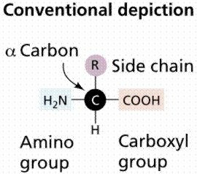
The structure of a generalized amino acid is shown at right. The amino group is found on the left side of the central carbon (also called alpha carbon), and the carboxyl group is found on the right side of the central carbon. Note that the R group is variable--this is why there are 20 different amino acids in living things.

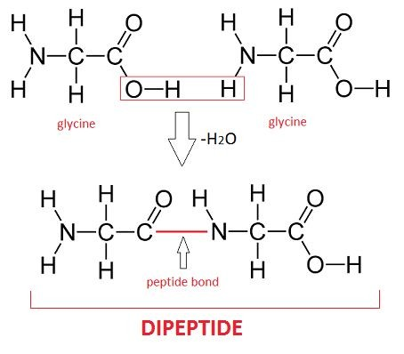
When two amino acids are joined together through the process of dehydration synthesis (a water molecule is removed by joining two monomers together), the resulting molecule is called a dipeptide:
Finally, when multiple amino acids are joined together by peptide bonds formed as a result of dehydration synthesis, the resulting molecule is known as a polypeptide. Note that the N--C--C backbone is the hallmark of protein molecules:
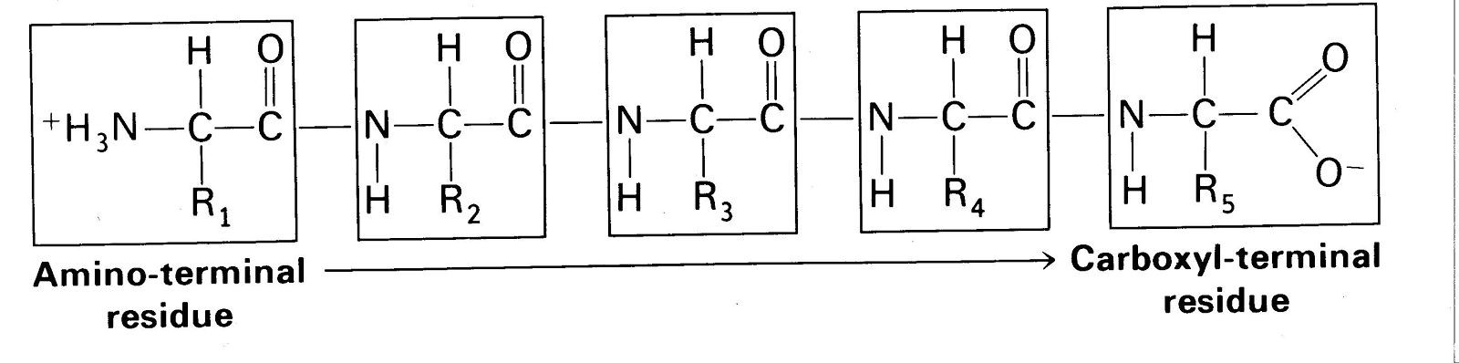

What You Will Turn In: The Deliverable
DIRECTIONS:
- In your BILL, create the heading “Generalized Amino Acid” and draw the structure for an amino acid. Label the amino group, carboxyl group, central carbon and R group.
- Now create the heading “Amino Acids” and paste the 9 amino acid molecule cards underneath. Highlight the atoms that comprise the backbone of each amino acid.
Each student will turn in the following:
  - A complete set of correctly identified and labeled molecule cutouts
    - This includes labeling the functional groups and molecule type
  - A completed biomolecules summary chart
  - A reflection of learning (written using complete sentences) that includes the following:
    - 3 things you learned about biomolecule structure
    - 2 things you learned about the similarity among the biologically important molecules
    - 1 thing you learned about biologically important molecules that you did not know before participating in this activity
  - You will need to use an app such as Tiny Scanner or CamScanner to snap photos of your work that can then be uploaded into Canvas as a pdf. Ask your teacher for help with this if you do not know how to do it.

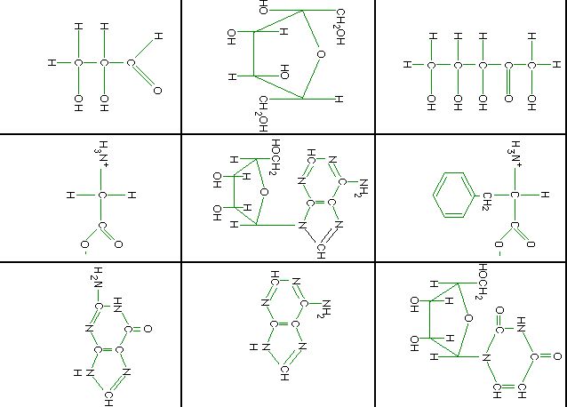
Molecule Cut-Outs: Use these to complete the activity.

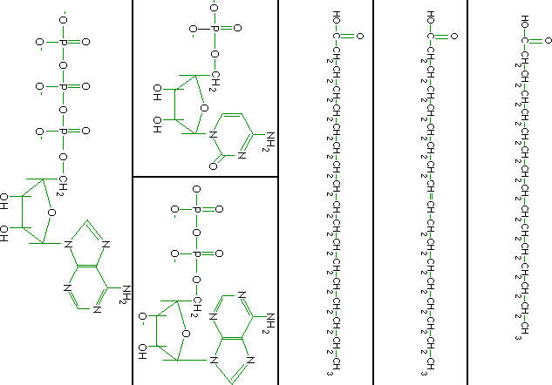
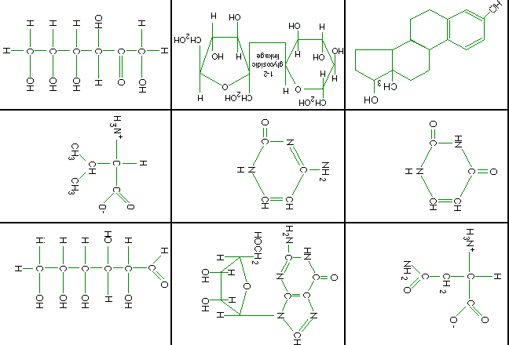

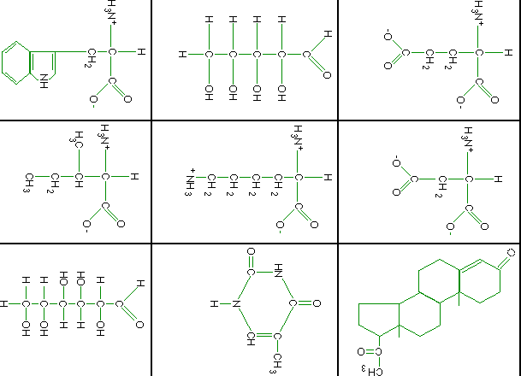

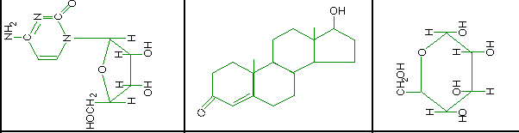

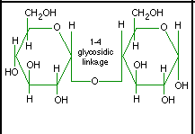

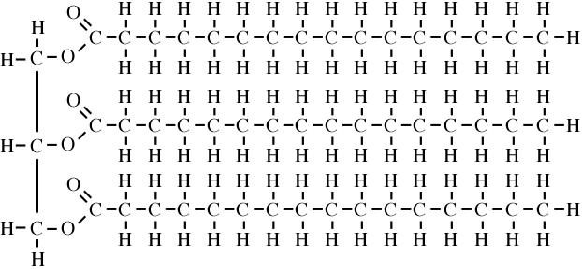 | 